**PROJECT REPORT**

1. **INTRODUCTION**

* 1. Overview

A job application tracking system is a software tool that helps employers manage and organize their recruitment process. It allows employers to post job openings, receive and review resumes, schedule interviews, and communicate with candidates all in one place. The system also helps employers track the progress of each candidate throughout the hiring process, from initial application to final hiring decision. This can help streamline the recruitment process and make it more efficient for both employers and candidates.

* 1. Purpose

The use of a job application tracking system can bring several benefits to a recruitment project. Here are some of the things that can be achieved using this system:

1. Centralized database: A job application tracking system allows you to store all candidate information in one place, making it easier to manage and organize.

2. Time-saving: The system automates many of the recruitment processes, such as resume screening and interview scheduling, which can save recruiters a lot of time.

3. Improved communication: The system allows recruiters to communicate with candidates more efficiently, keeping them informed about the status of their application and any updates.

4. Better candidate experience: The system can provide candidates with a more streamlined and professional experience, which can improve their perception of the company.

5. Data analysis: The system can provide valuable insights into the recruitment process, such as the effectiveness of job postings and the time-to-hire, which can help recruiters make data-driven decisions. Overall, a job application tracking system can help recruiters manage their recruitment process more efficiently, improve communication with candidates, and provide valuable insights into the recruitment process.

**2 Problem Definition & Design Thinking**

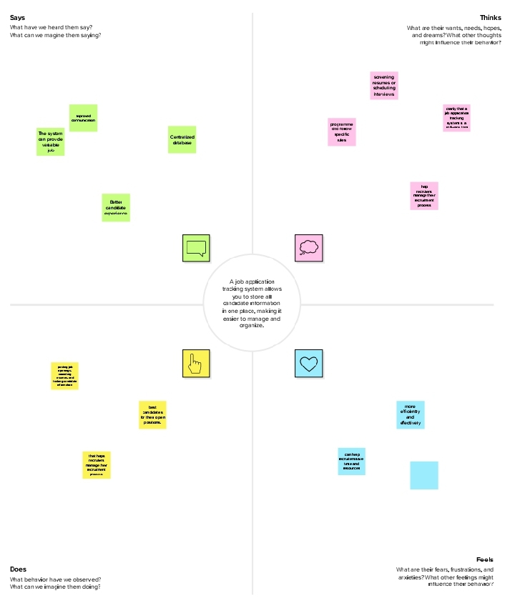 2.1 Empathy Map

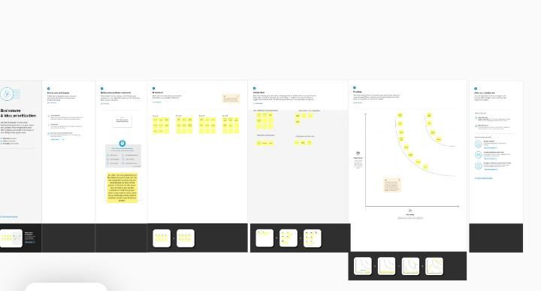 2.2 Ideation & Brainstorming Map

1. **RESULT**
   1. 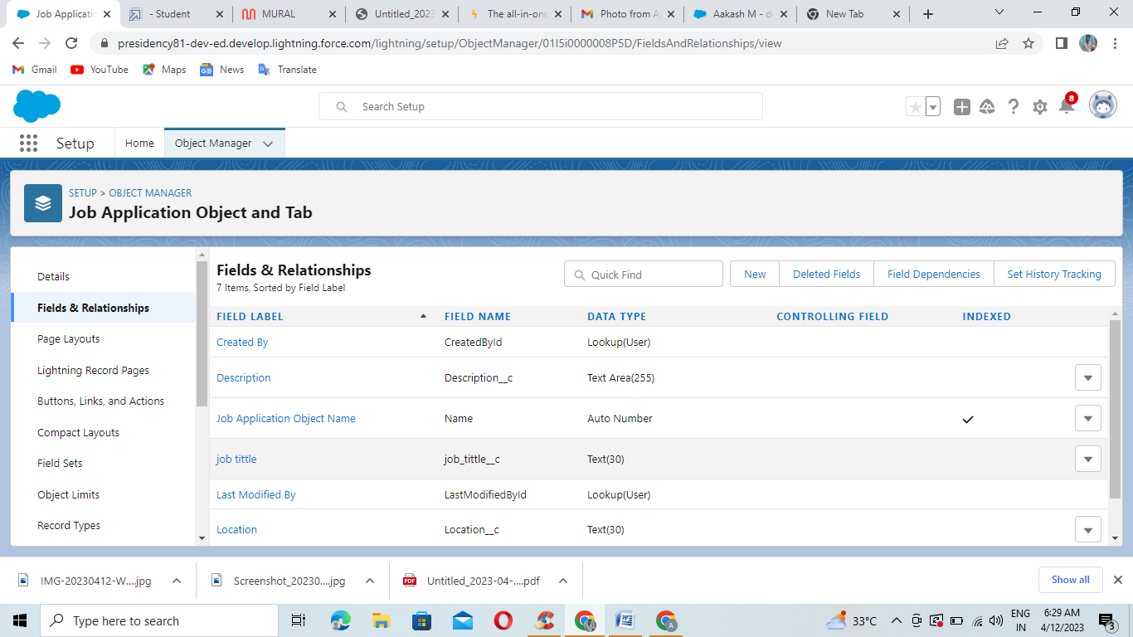Activity & Screenshot

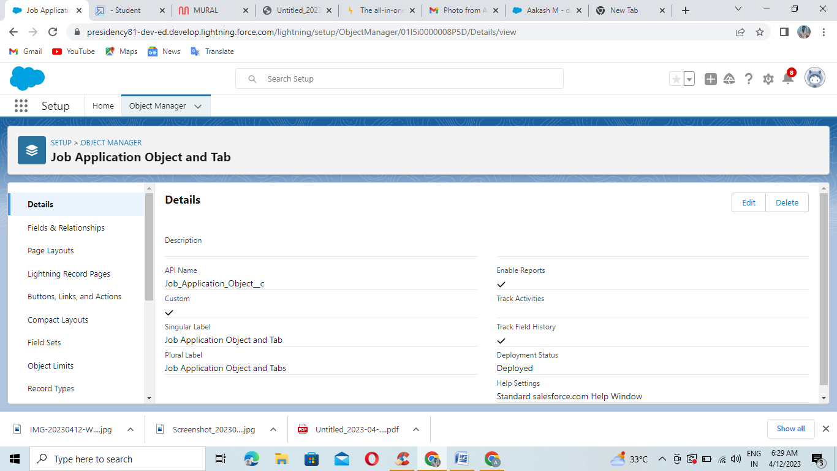

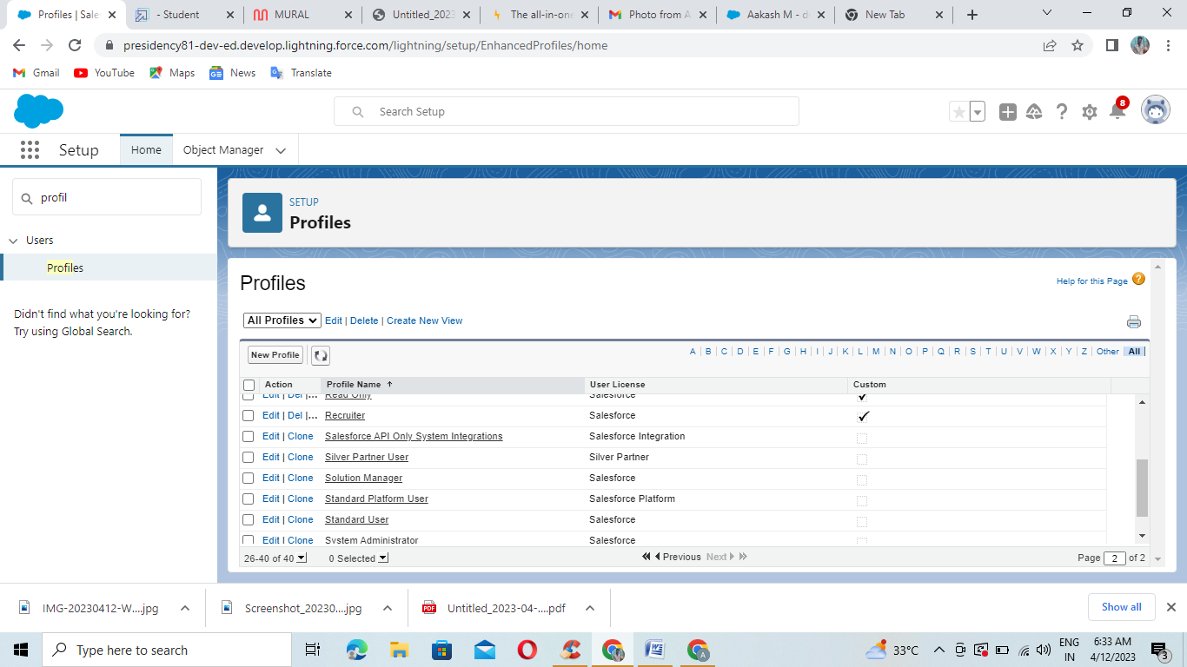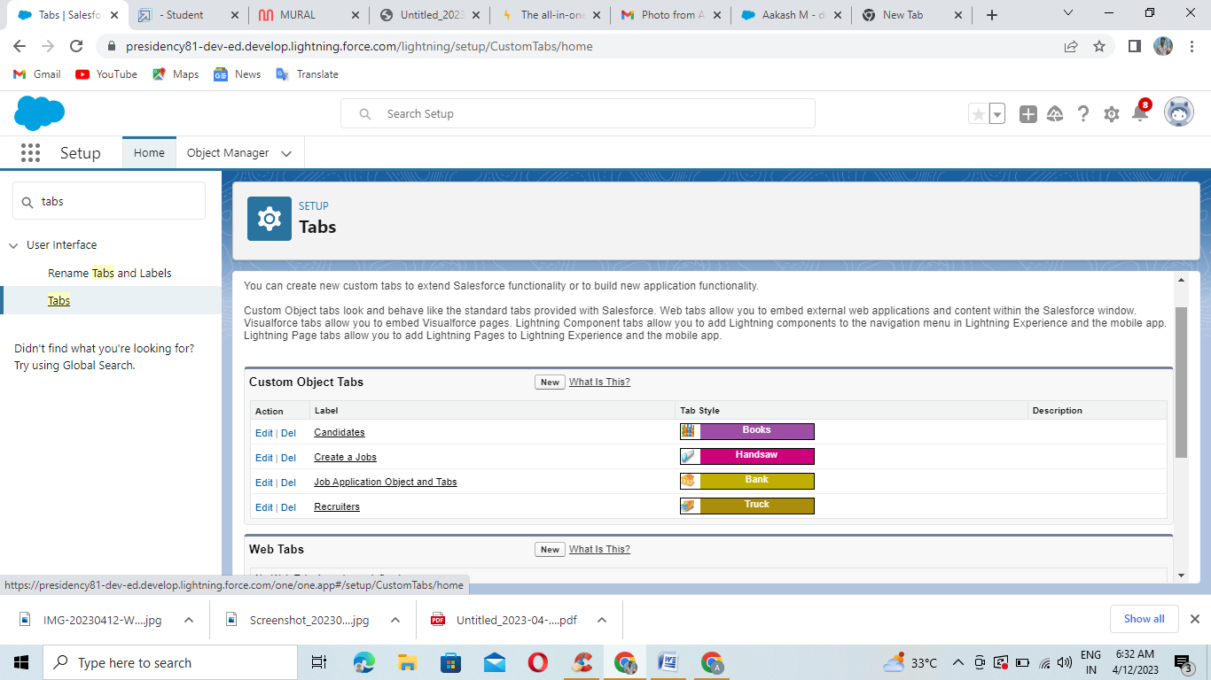

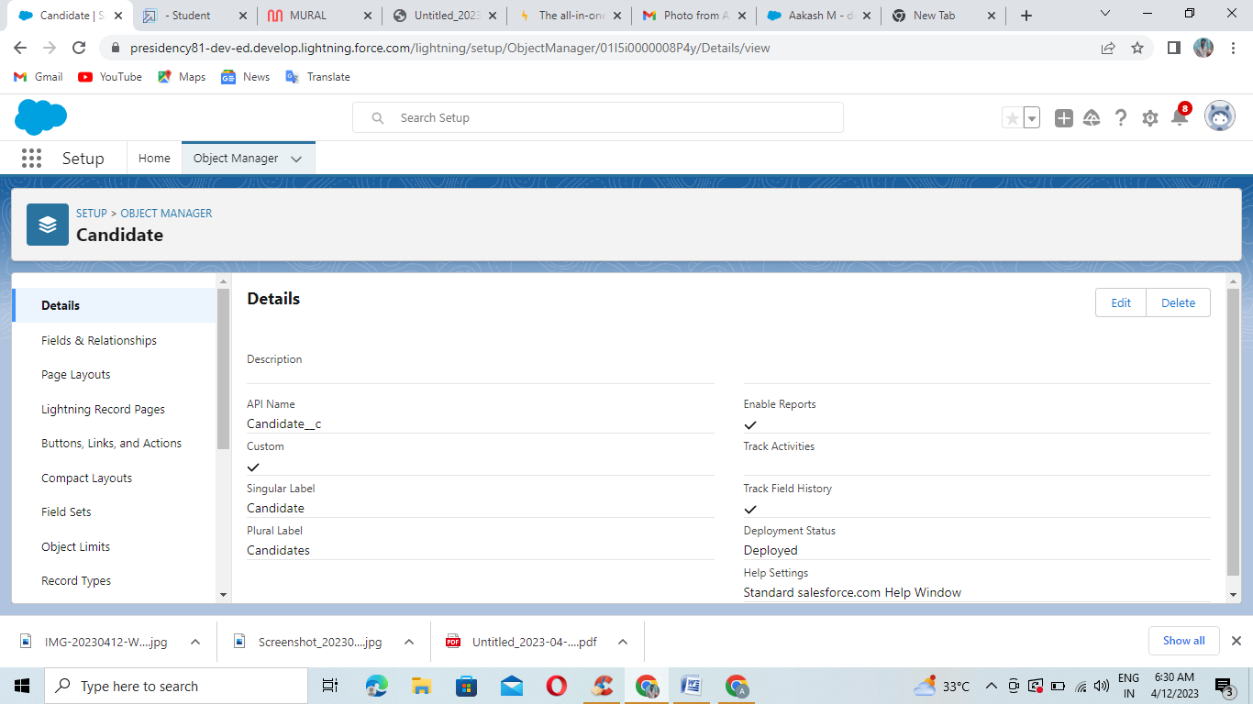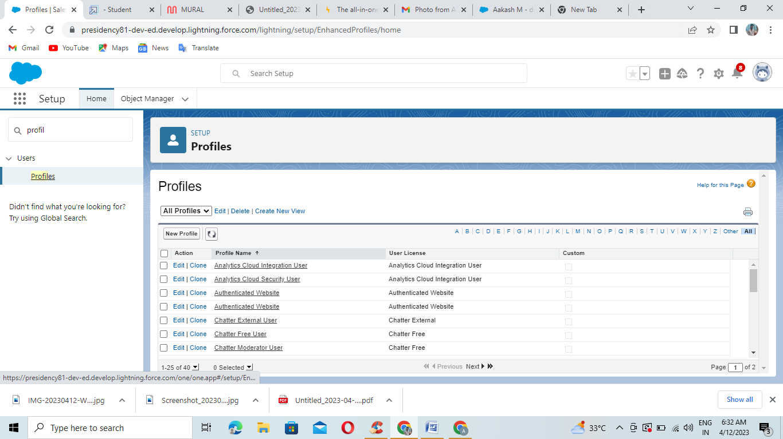

1. **Trailead Profile Public URl**

Team Lead - <https://trailblazer.me/id/aakam16>

Team Member 1 –<https://trailblazer.me/id/aakam16>

Team Member 2 -<https://trailblazer.me/id/aakam16>

Team Member 3 -<https://trailblazer.me/id/aakam16>

**5 ADVANTAGES & DISADVANTAGE**

Advantages:

1. Streamlined recruitment process: Job application tracking systems help recruiters to manage and track job applications efficiently, which saves time and effort.

2. Improved candidate experience: With job application tracking systems, candidates can easily apply for jobs and track their application status, which enhances their experience.

3. Better candidate screening: Job application tracking systems use algorithms to screen resumes and applications, which helps recruiters to identify the most qualified candidates.

4. Data-driven recruitment: Job application tracking systems provide valuable data and insights that can help recruiters to make informed decisions.

Disadvantages:

1. Cost: Job application tracking systems can be expensive, especially for small businesses.

2. Technical issues: Job application tracking systems can have technical issues, which can lead to lost applications or delayed responses.

3. Lack of personal touch: Job application tracking systems can make the recruitment process feel impersonal, which can negatively impact the candidate experience.

4. Bias: Job application tracking systems can perpetuate bias if the algorithms are not designed to be inclusive and unbiased.

1. **APPLICATIONS**

**A job application tracking system is a software tool that helps companies manage their recruitment process more efficiently. It allows recruiters to track and manage job applications, resumes, and candidate information in one centralized location. This system can help streamline the hiring process, reduce administrative tasks, and improve communication between recruiters and candidates. With the all-in-one AI platform, you can upgrade to increase your token limit with our Premium Membership and enjoy the benefits of a more efficient and effective recruitment process.**

1. **CONCLUSION**

**In conclusion, a job application tracking system is a valuable tool for companies looking to streamline their recruitment process. It allows recruiters to manage job applications, resumes, and candidate information in one centralized location, reducing administrative tasks and improving communication between recruiters and candidates. With the all-in-one AI platform, you can upgrade to our Premium Membership and increase your token limit, giving you access to even more features and benefits to help you find the best candidates for your organization**

**8 FUTURE SCOPE**

**The future scope of job application tracking systems is promising. As technology continues to advance, these systems will become even more sophisticated and efficient. Some potential future developments include the integration of artificial intelligence and machine learning to help recruiters identify the best candidates more quickly and accurately. Additionally, there may be more emphasis on mobile-friendly interfaces and the use of chatbots to improve communication with candidates. Overall, the future of job application tracking systems looks bright, and they will continue to play a crucial role in the recruitment process for many organizations.**